WEEK-4

COURSE : PROBLEM SOLVING AND TESTING USING JAVA
COURSE CODE : 10211CS227
NAME : D.VAMSI
VTUNO : 27781

TASKS :
1.DETERMINE IF STRING HALVES ARE ALIKE
2.LAPINDROME
3.COMPARE THE TRIPLETS
4.CONTAIN DUPLICATES
5.TIME CONVERSION
6.MIVE ZEROES
7.DIAGONAL DIFFERENCE
8.TRANSPOSE MATRIX
9.MATRIX BLOCKS SUM
10.MATRIX NOTATION ALGORITHM
1.You are given a string s of even length. Split this string into two halves of equal lengths, and let a be the first half and b be the second half.

Two strings are alike if they have the same number of vowels ('a', 'e', 'i', 'o', 'u', 'A', 'E', 'I', 'O', 'U'). Notice that s contains uppercase and lowercase letters.

Return true if a and b are alike. Otherwise, return false.
Example 1:
Input: s = "book"
Output: true
Explanation: a = "bo" and b = "ok". a has 1 vowel and b has 1 vowel. Therefore, they are alike.
Example 2:
Input: s = "textbook"
Output: false
Explanation: a = "text" and b = "book". a has 1 vowel whereas b has 2. Therefore, they are not alike.
Notice that the vowel o is counted twice.
Constraints: 2 <= s.length <= 1000 s.length is even.
s consists of uppercase and lowercase letters.

Program:
class Solution {
public boolean halvesAreAlike(String s) { String vowels = "aeiouAEIOU"; int count = 0; int n = s.length();
for (int i = 0; i < n / 2; i++) { if (vowels.indexOf(s.charAt(i)) != -1) { count++;
}
if (vowels.indexOf(s.charAt(i + n / 2)) != -1) { count--;
}
}
return count == 0;
}
}
Output:
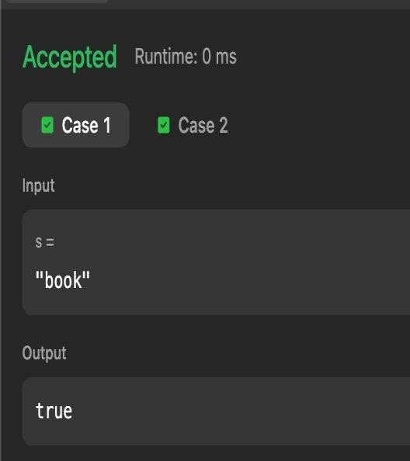

2. Lapindrome is defined as a string which when split in the middle, gives two halves having the same characters and same frequency of each character. If there are odd number of characters in the string, we ignore the middle character and check for lapindrome. For example gaga is a lapindrome, since the two halves ga and ga have the same characters with same frequency. Also, abccab, rotor and xyzxy are a few examples of lapindromes. Note that abbaab is NOT a lapindrome. The two halves contain the same characters but their frequencies do not match.
Your task is simple. Given a string, you need to tell if it is a lapindrome.
Input:
First line of input contains a single integer T, the number of test cases.
Each test is a single line containing a string S composed of only lowercase English alphabet.

Output:
For each test case, output on a separate line: "YES" if the string is a lapindrome and "NO" if it is not.

Constraints:
- 1 ≤ T ≤ 100
- 2 ≤ |S| ≤ 1000, where |S| denotes the length of S

Program:
import java.util.*; import java.lang.*; import java.io.*; class Codechef {
public static void main(String[] args) throws java.lang.Exception { Scanner sc = new Scanner(System.in); if (!sc.hasNextInt()) return; int t = sc.nextInt(); while (t-- > 0) { String s = sc.next(); int len = s.length();
String left = s.substring(0, len / 2); String right = s.substring((len + 1)/2; char[] leftArr = left.toCharArray(); char[] rightArr = right.toCharArray();
Arrays.sort(leftArr);
Arrays.sort(rightArr);
if (Arrays.equals(leftArr, rightArr)) {
System.out.println("YES");
} else {
System.out.println("NO");
}
}
sc.close();
}
}
Output:
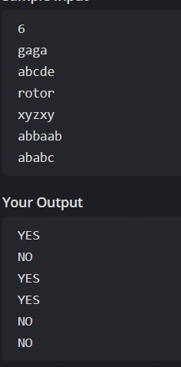

3.Alice and Bob each created one problem for HackerRank. A reviewer rates the two challenges, awarding points on a scale from 1 to 100 for three categories: problem clarity, originality, and difficulty.
The rating for Alice's challenge is the triplet a = (a[0], a[1], a[2]), and the rating for Bob's challenge is the triplet b = (b[0], b[1], b[2]).
The task is to calculate their comparison points by comparing each category:
If a[i] > b[i], then Alice is awarded 1 point.
If a[i] < b[i], then Bob is awarded 1 point.
If a[i] = b[i], then neither person receives a point. Example
a = [1, 2, 3] b = [3, 2, 1]
For elements *0*, Bob is awarded a point because a[0] < b[0].
For the equal elements a[1] and b[1], no points are earned.
Finally, for elements 2, a[2] > b[2] so Alice receives a point.
The return array is [1, 1] with Alice's score first and Bob's second.
Function Description
Complete the function compareTriplets with the following parameter(s):
int a[3]: Alice's challenge rating int b[3]: Bob's challenge rating Returns
int[2]: the first element is Alice's score and the second is Bob's score
Input Format
The first line contains 3 space-separated integers, a[0], a[1], and a[2], the respective values in triplet a.
The second line contains 3 space-separated integers, b[0], b[1], and b[2], the respective values in triplet b.
Constraints
1 ≤ a[i] ≤ 100
1 ≤ b[i] ≤ 100
Sample Input 0:
5 6 7
3 6 10
Sample Output 0:
1 1

Program:
import java.io.*; import java.math.*; import java.security.*; import java.text.*; import java.util.*; import java.util.concurrent.*; import java.util.function.*; import java.util.regex.*; import java.util.stream.*; import static java.util.stream.Collectors.joining; import static java.util.stream.Collectors.toList; class Result { public static List<Integer> compareTriplets(List<Integer> a, List<Integer> b) { int alice = 0; int bob = 0; for (int i = 0; i < 3; i++) { if (a.get(i) > b.get(i)) { alice++;
} else if (a.get(i) < b.get(i)) { bob++;
}
}
List<Integer> result = new ArrayList<>(); result.add(alice); result.add(bob); return result;
}
}
public class Solution {
public static void main(String[] args) throws IOException {
BufferedReader bufferedReader = new BufferedReader(new InputStreamReader(System.in));
BufferedWriter bufferedWriter = new BufferedWriter(new
FileWriter(System.getenv("OUTPUT_PATH")));
List<Integer> a = Stream.of(bufferedReader.readLine().replaceAll("\\s+$", "").split("
"))
.map(Integer::parseInt)
.collect(toList());
List<Integer> b = Stream.of(bufferedReader.readLine().replaceAll("\\s+$", "").split("
"))
.map(Integer::parseInt)
.collect(toList());
List<Integer> result = Result.compareTriplets(a, b); bufferedWriter.write( result.stream()
.map(Object::toString)
.collect(joining(" "))
+ "\n"
);
bufferedReader.close(); bufferedWriter.close();
}
}

Output:
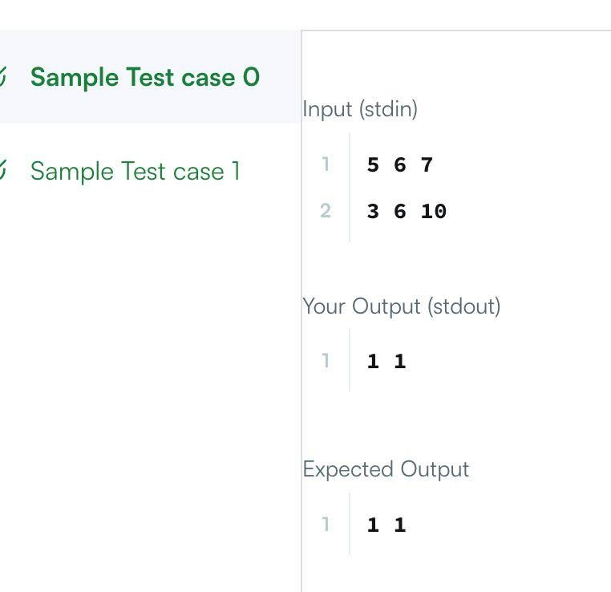

4.Given an integer array nums, return true if any value appears at least twice in the array, and return false if every element is distinct.
Example 1:
Input: nums = [1,2,3,1]

Output: true
Explanation:
The element 1 occurs at the indices 0 and 3.
Example 2:
Input: nums = [1,2,3,4]
Output: false Explanation:
All elements are distinct.
Example 3:
Input: nums = [1,1,1,3,3,4,3,2,4,2]
Output: true
Constraints:
1 <= nums.length <= 105
-109 <= nums[i] <= 109

Program: import java.util.HashSet; class Solution {
public boolean containsDuplicate(int[] nums) { HashSet<Integer> set = new HashSet<>(); for (int num : nums) { if (set.contains(num)) { return true;
}
set.add(num);
}
return false;
}
}

Output:
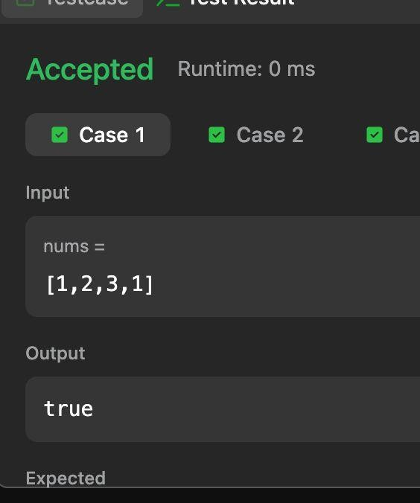

5.Given a time in -hour AM/PM format, convert it to military (24-hour) time.
Note: - 12:00:00AM on a 12-hour clock is 00:00:00 on a 24-hour clock.
- 12:00:00PM on a 12-hour clock is 12:00:00 on a 24-hour clock.
Example
Return '12:01:00'.
Return '00:01:00'.

Function Description
Complete the function with the following parameter(s):
: a time in hour format
Returns
: the time in hour format
Input Format
A single string that represents a time in -hour clock format (i.e.: or ).
Constraints
All input times are valid
Sample Input 0
07:05:45PM
Sample Output 0
19:05:45

Program:
import java.io.*; import java.math.*; import java.security.*; import java.text.*; import java.util.*; import java.util.concurrent.*; import java.util.function.*; import java.util.regex.*; import java.util.stream.*; import static java.util.stream.Collectors.joining; import static java.util.stream.Collectors.toList;

class Result { public static String timeConversion(String s) {
// Extract the period (AM or PM) from the last two characters
String period = s.substring(s.length() - 2);
// Extract the numerical time portion (hh:mm:ss)
String time = s.substring(0, s.length() - 2);
// Split into components: [hours, minutes, seconds] String[] parts = time.split(":"); int hours = Integer.parseInt(parts[0]); if (period.equalsIgnoreCase("AM")) {
// Special case: 12 AM becomes 00 in 24-hour time
if (hours == 12) { hours = 0;
}
} else {
// Special case: 12 PM stays 12; all other PM hours add 12 if (hours != 12) { hours += 12;
}
}
// Format hours back to 2 digits with leading zero if necessary return String.format("%02d:%s:%s", hours, parts[1], parts[2]); }
}
public class Solution {
public static void main(String[] args) throws IOException {
BufferedReader bufferedReader = new BufferedReader(new InputStreamReader(System.in));
BufferedWriter bufferedWriter = new BufferedWriter(new
FileWriter(System.getenv("OUTPUT_PATH")));
String s = bufferedReader.readLine(); String result = Result.timeConversion(s); bufferedWriter.write(result); bufferedWriter.newLine(); bufferedReader.close(); bufferedWriter.close();
}
}
Output:
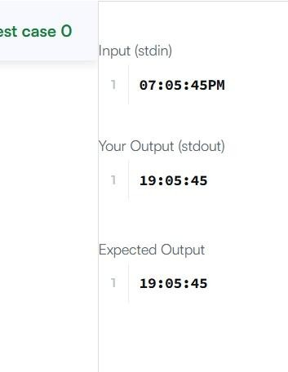

6.Given an integer array nums, move all 0's to the end of it while maintaining the relative order of the non-zero elements.

Note that you must do this in-place without making a copy of the array.
Example 1:
Input: nums = [0,1,0,3,12]
Output: [1,3,12,0,0] Example 2:
Input: nums = [0]
Output: [0]
Constraints:
1 <= nums.length <= 104
-231 <= nums[i] <= 231 – 1

Program:
class Solution { public void moveZeroes(int[] nums) {
int index = 0;
// Move all non-zero elements to the front for (int i = 0; i < nums.length; i++) { if (nums[i] != 0) { nums[index] = nums[i]; index++;
}
}
// Fill the remaining positions with 0 while (index < nums.length) { nums[index] = 0; index++;
}
}
}

Output:
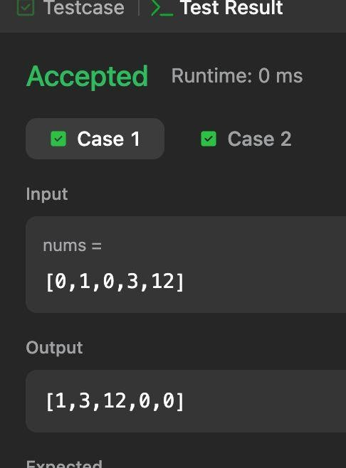

7.Given a square matrix, calculate the absolute difference between the sums of its diagonals.
For example, the square matrix is shown below:
1 2 3
4 5 6
9 8 9
The left-to-right diagonal = .
The right-to-left diagonal = .
Their absolute difference is .
Function description
Complete the function with the following parameter:
: a 2-D array of integers
Return
: the absolute difference in sums along the diagonals
Input Format
The first line contains a single integer, , the number of rows and columns in the square matrix .
Each of the next lines describes a row, , and consists of space-separated integers . STDIN Function
----- --------
3 arr[][] sizes n = 3, m = 3
11 2 4 arr = [[11, 2, 4], [4, 5, 6], [10, 8, -12]]
4 5 6
10 8 -12
Sample Output

15
Explanation
The primary diagonal is:
11
5
-12
Sum across the primary diagonal: .
The secondary diagonal is:
4
5 10 Sum across the secondary diagonal:
Difference:
Note: |x| is the absolute value of x.

Program:
import java.io.*; import java.math.*; import java.security.*; import java.text.*; import java.util.*; import java.util.concurrent.*; import java.util.function.*; import java.util.regex.*; import java.util.stream.*; import static java.util.stream.Collectors.joining; import static java.util.stream.Collectors.toList;

class Result { public static int diagonalDifference(List<List<Integer>> arr) { int primary = 0; int secondary = 0; int n = arr.size(); for (int i = 0; i < n; i++) { primary += arr.get(i).get(i); secondary += arr.get(i).get(n - 1 - i);
}
return Math.abs(primary - secondary);
}
}
public class Solution {
public static void main(String[] args) throws IOException {
BufferedReader bufferedReader = new BufferedReader(new
InputStreamReader(System.in));
BufferedWriter bufferedWriter = new BufferedWriter(new FileWriter(System.getenv("OUTPUT_PATH")));
int n = Integer.parseInt(bufferedReader.readLine().trim());
List<List<Integer>> arr = new ArrayList<>(); IntStream.range(0, n).forEach(i -> { try { arr.add(
Stream.of(bufferedReader.readLine().replaceAll("\\s+$", "").split(" "))
.map(Integer::parseInt)
.collect(toList())
);
} catch (IOException ex) { throw new RuntimeException(ex);
}
});
int result = Result.diagonalDifference(arr); bufferedWriter.write(String.valueOf(result)); bufferedWriter.newLine(); bufferedReader.close(); bufferedWriter.close();
}
}
Output:
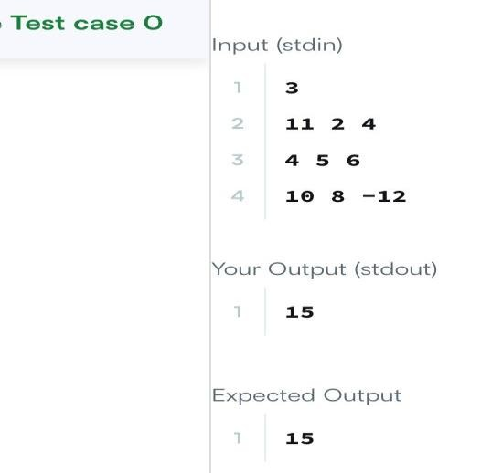

8.Given a 2D integer array matrix, return the transpose of matrix.
The transpose of a matrix is the matrix flipped over its main diagonal, switching the matrix's row and column indices.
Example 1:
Input: matrix = [[1,2,3],[4,5,6],[7,8,9]]
Output: [[1,4,7],[2,5,8],[3,6,9]] Example 2:
Input: matrix = [[1,2,3],[4,5,6]]
Output: [[1,4],[2,5],[3,6]] Constraints:
m == matrix.length n == matrix[i].length 1 <= m, n <= 1000
1 <= m * n <= 105
-109 <= matrix[i][j] <= 109

Program:
class Solution { public int[][] transpose(int[][] matrix) { int m = matrix.length;
int n = matrix[0].length; int[][] result = new int[n][m]; for (int i = 0; i < m; i++) { for (int j = 0; j < n; j++) { result[j][i] = matrix[i][j];
}
}
return result;
}
}

Output:
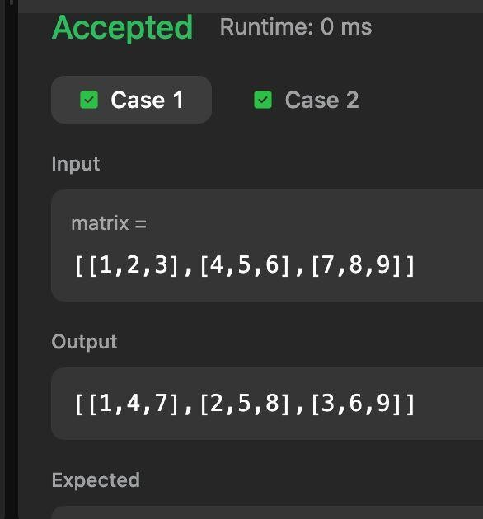

9.Given a m x n matrix mat and an integer k, return a matrix answer where each answer[i][j] is the sum of all elements mat[r][c] for:
i - k <= r <= i + k, j - k <= c <= j + k, and
(r, c) is a valid position in the matrix.
Example 1:
Input: mat = [[1,2,3],[4,5,6],[7,8,9]], k = 1 Output: [[12,21,16],[27,45,33],[24,39,28]] Example 2:
Input: mat = [[1,2,3],[4,5,6],[7,8,9]], k = 2 Output: [[45,45,45],[45,45,45],[45,45,45]] Constraints: m == mat.length n == mat[i].length
1 <= m, n, k <= 100
1 <= mat[i][j] <= 100

Program: class Solution { public int[][] matrixBlockSum(int[][] mat, int k) { int m = mat.length; int n = mat[0].length; int[][] prefix = new int[m + 1][n + 1]; // Build prefix sum matrix for (int i = 1; i <= m; i++) { for (int j = 1; j <= n; j++) { prefix[i][j] = mat[i - 1][j - 1]
+ prefix[i - 1][j] + prefix[i][j - 1]
- prefix[i - 1][j - 1];
}
}

int[][] answer = new int[m][n];
// Calculate block sums
for (int i = 0; i < m; i++) { for (int j = 0; j < n; j++) { int r1 = Math.max(0, i - k); int c1 = Math.max(0, j - k); int r2 = Math.min(m - 1, i + k); int c2 = Math.min(n - 1, j + k); answer[i][j] = prefix[r2 + 1][c2 + 1]
- prefix[r1][c2 + 1] - prefix[r2 + 1][c1]
+ prefix[r1][c1];
}
}
return answer;
}
}

Output:
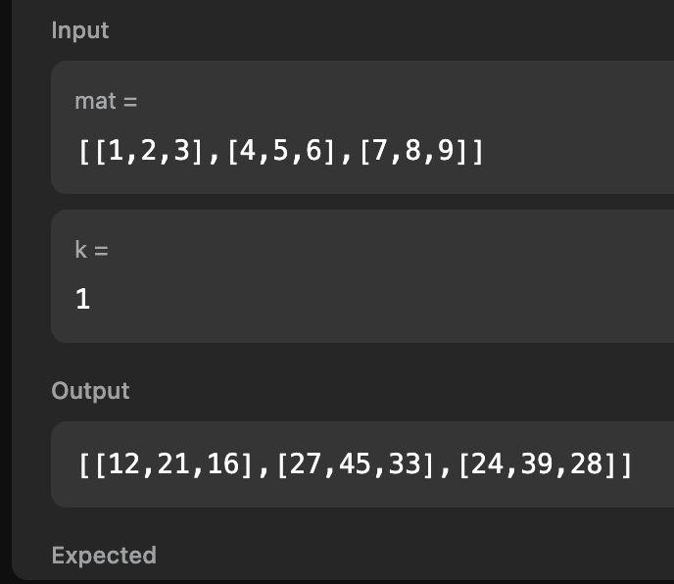

10.You are given a 2D matrix of dimension and a positive integer . You have to rotate the matrix times and print the resultant matrix. Rotation should be in anti-clockwise direction.

Rotation of a matrix is represented by the following figure. Note that in one rotation, you have to shift elements by one step only.
matrix-rotation
It is guaranteed that the minimum of m and n will be even.
As an example rotate the Start matrix by 2:

Start First Second
1 2 3 4 2 3 4 5 3 4 5 6
12 1 2 5 -> 1 2 3 6 -> 2 3 4 7
11 4 3 6 12 1 4 7 1 2 1 8
10 9 8 7 11 10 9 8 12 11 10 9
Function Description
Complete the matrixRotation function in the editor below.
matrixRotation has the following parameter(s):
int matrix[m][n]: a 2D array of integers int r: the rotation factor
Prints
It should print the resultant 2D integer array and return nothing. Print each row on a separate line as space-separated integers.
Input Format

The first line contains three space separated integers, , , and , the number of rows and columns in , and the required rotation.
The next lines contain space-separated integers representing the elements of a row of .
Sample Input #01

STDIN Function
----- --------
4 4 2 rows m = 4, columns n = 4, rotation factor r = 2
1 2 3 4 matrix = [[1, 2, 3, 4], [5, 6, 7, 8], [9, 10, 11, 12], [13, 14, 15, 16]]
5 6 7 8
9 10 11 12
13 14 15 16
Sample Output #01

3 4 8 12
2 11 10 16
1 7 6 15
5 9 13 14
Explanation #01

The matrix is rotated through two rotations.

1 2 3 4 2 3 4 8 3 4 8 12
5 6 7 8 1 7 11 12 2 11 10 16
9 10 11 12 -> 5 6 10 16 -> 1 7 6 15
13 14 15 16 9 13 14 15 5 9 13 14
Sample Input #0
5 4 7
1 2 3 4
7 8 9 10
13 14 15 16
19 20 21 22
25 26 27 28
Sample Output #02
28 27 26 25
22 9 15 19
16 8 21 13
10 14 20 7
4 3 2 1

Program:
mport java.io.*; import java.math.*; import java.security.*; import java.text.*; import java.util.*; import java.util.concurrent.*; import java.util.function.*; import java.util.regex.*; import java.util.stream.*; import static java.util.stream.Collectors.joining; import static java.util.stream.Collectors.toList; class Result { public static void matrixRotation(List<List<Integer>> matrix, int r) { int m = matrix.size(); int n = matrix.get(0).size(); int[][] ans = new int[m][n]; int layers = Math.min(m, n) / 2; for (int layer = 0; layer < layers; layer++) { List<Integer> list = new ArrayList<>();
// Top for (int j = layer; j < n - layer; j++) list.add(matrix.get(layer).get(j));
// Right for (int i = layer + 1; i < m - layer - 1; i++) list.add(matrix.get(i).get(n - layer - 1));
// Bottom for (int j = n - layer - 1; j >= layer; j--) list.add(matrix.get(m - layer - 1).get(j));
// Left for (int i = m - layer - 2; i > layer; i--) list.add(matrix.get(i).get(layer)); int size = list.size(); int rot = r % size; int idx = rot; // Top for (int j = layer; j < n - layer; j++) ans[layer][j] = list.get((idx++) % size);
// Right for (int i = layer + 1; i < m - layer - 1; i++) ans[i][n - layer - 1] = list.get((idx++) % size);

// Bottom for (int j = n - layer - 1; j >= layer; j--) ans[m - layer - 1][j] = list.get((idx++) % size);
// Left for (int i = m - layer - 2; i > layer; i--) ans[i][layer] = list.get((idx++) % size); }
for (int i = 0; i < m; i++) { for (int j = 0; j < n; j++) { System.out.print(ans[i][j]);
if (j != n - 1)
System.out.print(" ");
}
System.out.println();
}
}
}
public class Solution {
public static void main(String[] args) throws IOException {
BufferedReader bufferedReader = new BufferedReader(new InputStreamReader(System.in));

String[] firstMultipleInput = bufferedReader.readLine().replaceAll("\\s+$", "").split("
");
int m = Integer.parseInt(firstMultipleInput[0]); int n = Integer.parseInt(firstMultipleInput[1]); int r = Integer.parseInt(firstMultipleInput[2]);
List<List<Integer>> matrix = new ArrayList<>(); IntStream.range(0, m).forEach(i -> { try {
matrix.add(
Stream.of(bufferedReader.readLine().replaceAll("\\s+$", "").split(" "))
.map(Integer::parseInt)
.collect(toList())
);
} catch (IOException ex) { throw new RuntimeException(ex);
}
});
Result.matrixRotation(matrix, r); bufferedReader.close();
}
}
Output:
